

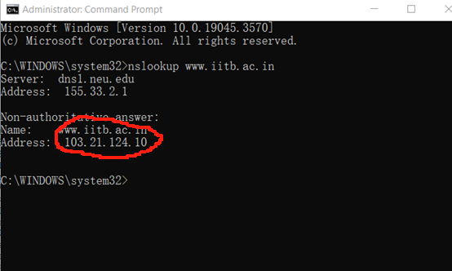

IP address is： 103.21.124.10



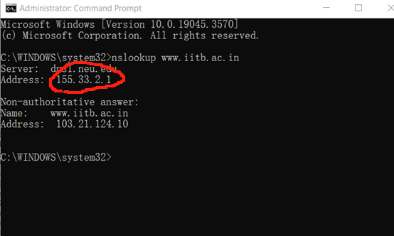

IP Address： 155.33.2.1



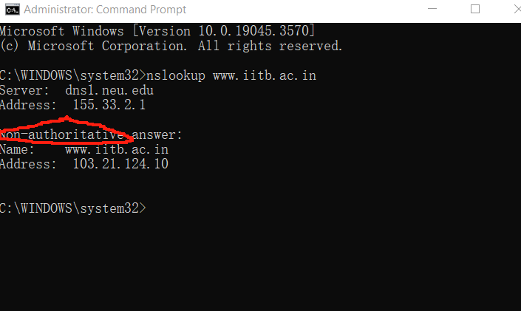

From a Non- authoritative server

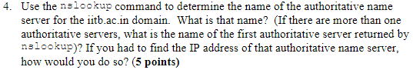

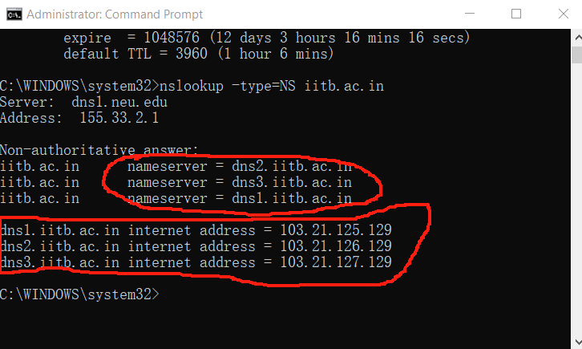

The first authoritative server is : dns2.iitb.ac.in

Run command nslookup -type=NS iitb.ac.in. The IP address will show.

ip.addr == 10.110.249.61

<http://gaia.cs.umass.edu/kurose_ross/>

Q5: Locate the first DNS query message resolving the name gaia.cs.umass.edu. What is the packet number in the trace for the DNS query message? Is this query message sent over UDP or TCP?

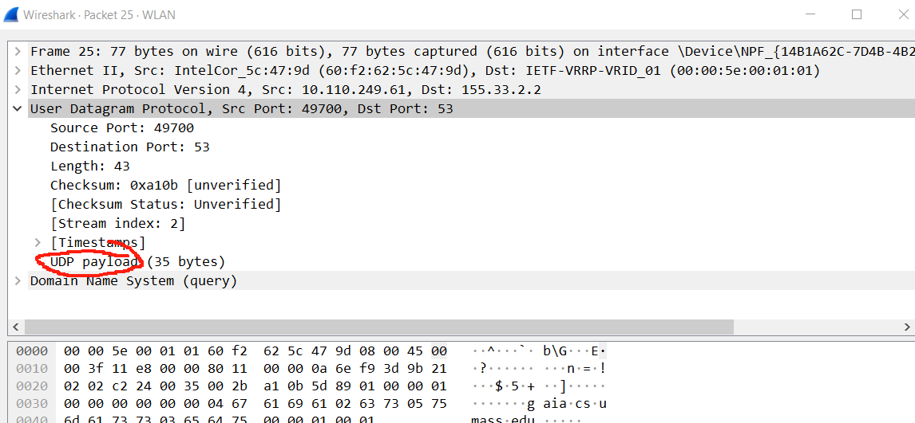

Q6: Now locate the corresponding DNS response to the initial DNS query. What is the packet number in the trace for the DNS response message? Is this response message received via UDP or TCP?

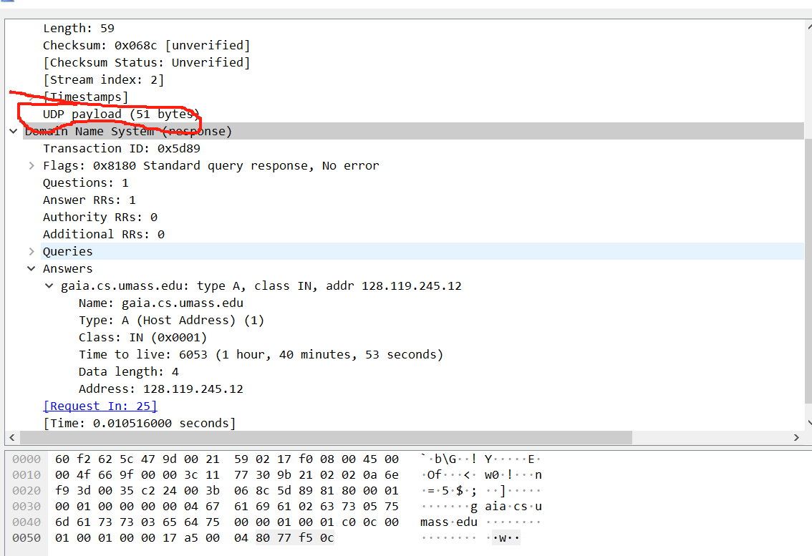

A: The destination port for the DNS query message is 53. The source port of the DNS response message is 53.



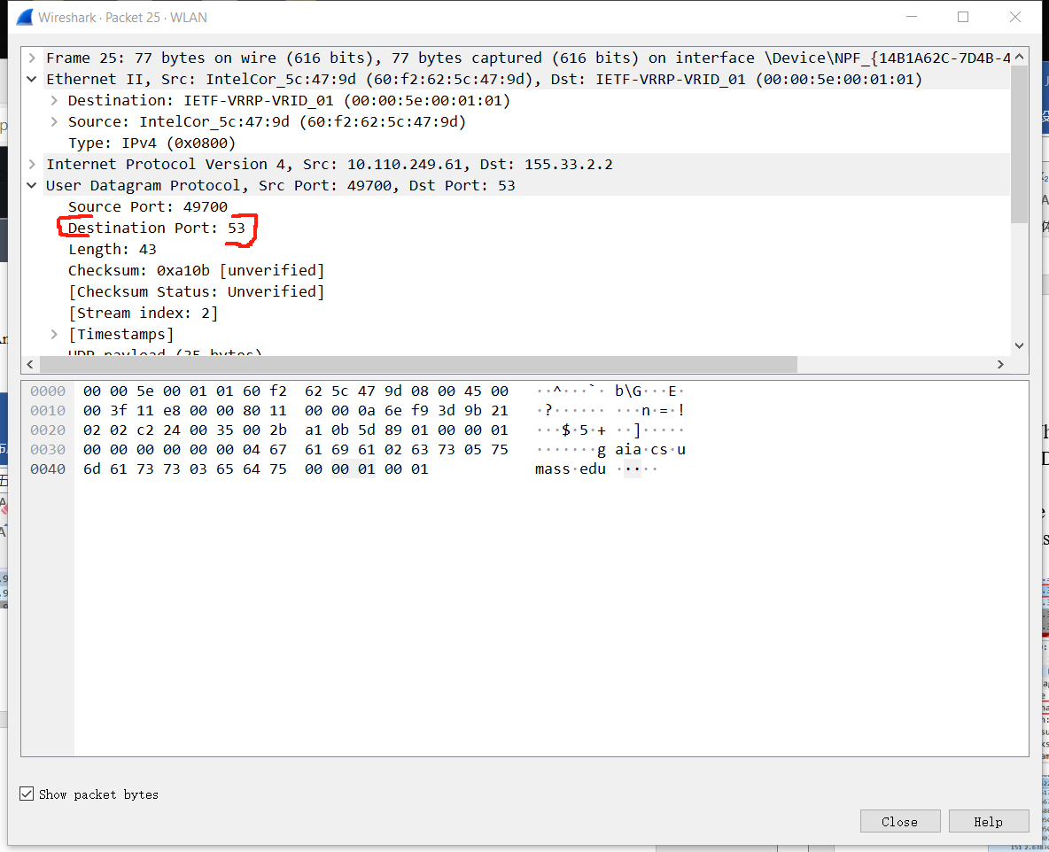

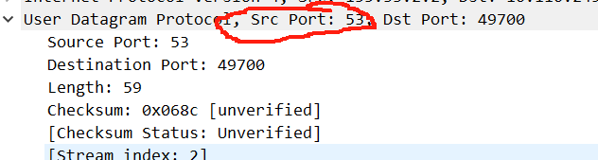

Q8: To what IP address is the DNS query message sent?

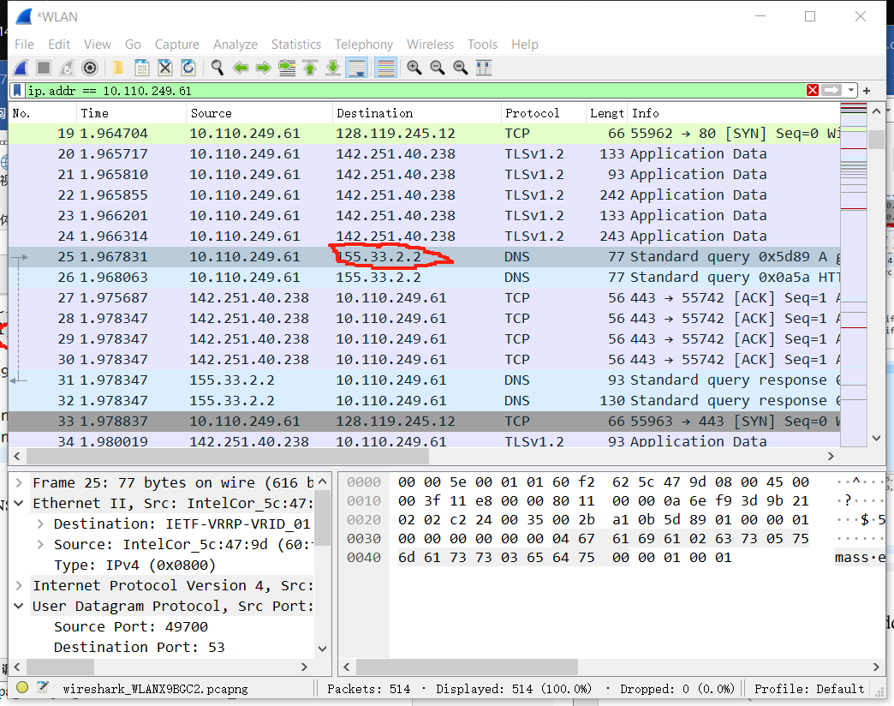

155.33.2.2

10. Examine the DNS response message to the initial query message. How many“questions” does this DNS message contain? How many “answers” answers does it contain? (4 point

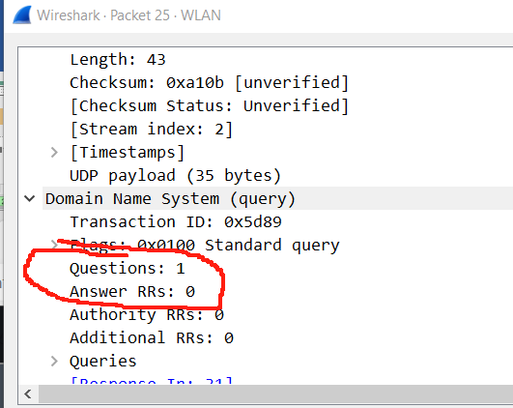

Q11: This web page contains images. Before retrieving each image, does your host issue new DNS queries?

11. This web page contains images. Before retrieving each image, does your host issue new DNS queries? (2.5 point

No

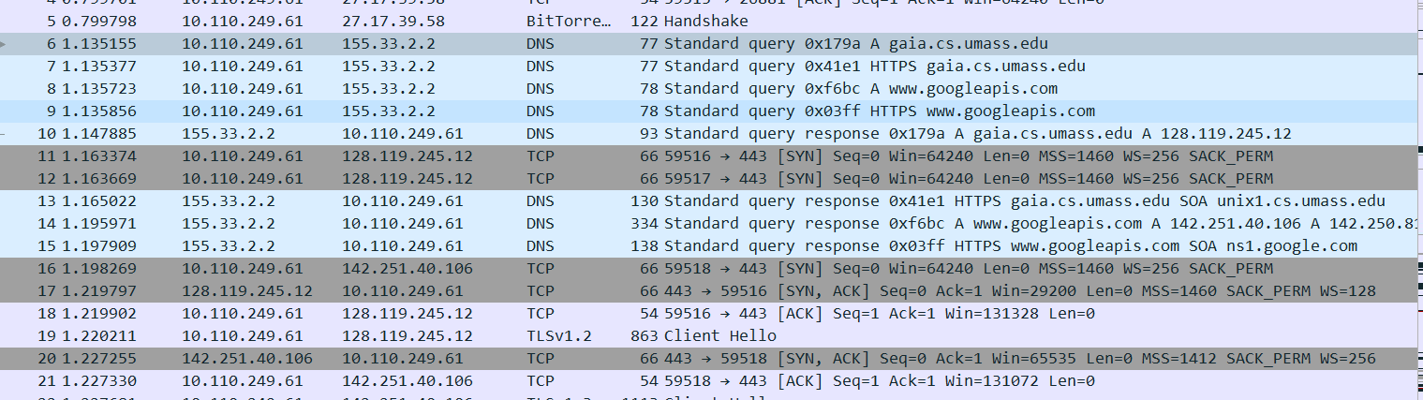

Q12: What is the destination port for the DNS query message? What is the source port of the DNS response message?

A: The destination port for the DNS query message is 53. The source port of the DNS response message is 53.

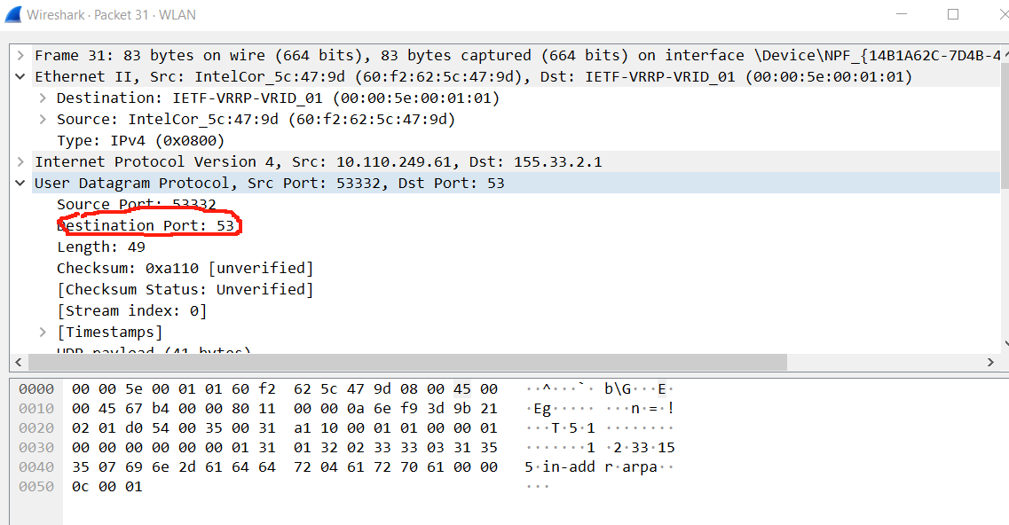

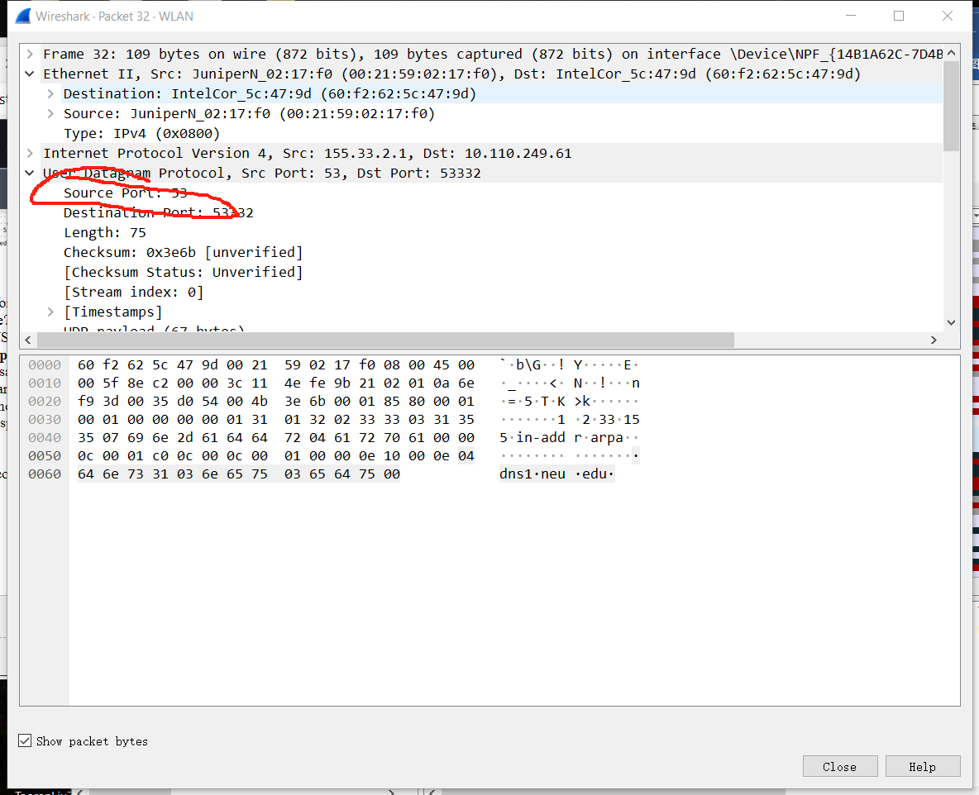

13. To what IP address is the DNS query message sent? Is this the IP address of your

default local DNS server? (4 points)

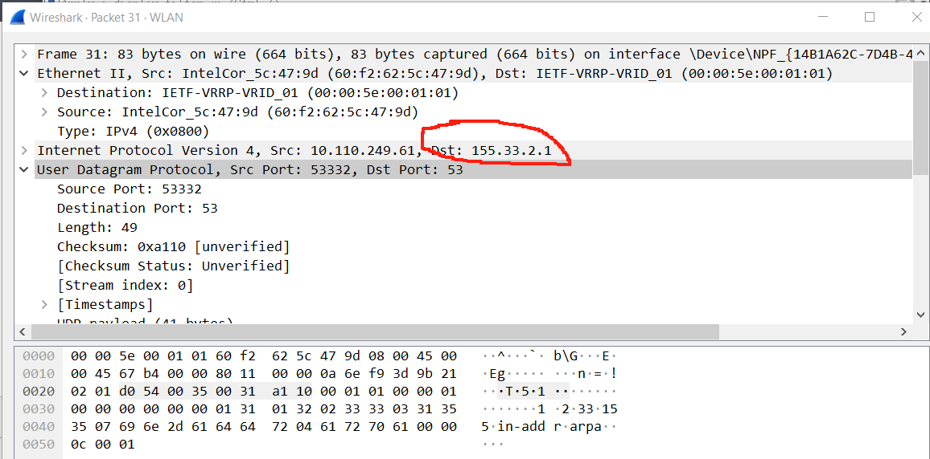

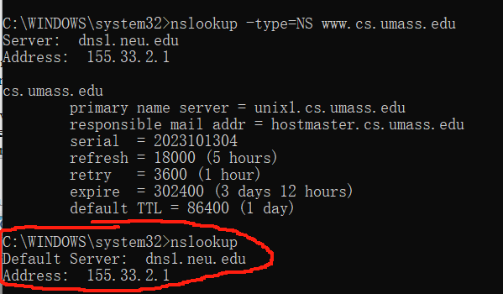

Yes

Q14: Examine the DNS query message. What “Type” of DNS query is it? Does the query message contain any “answers” ?

A: The type is A. No, it does not contain any answer.

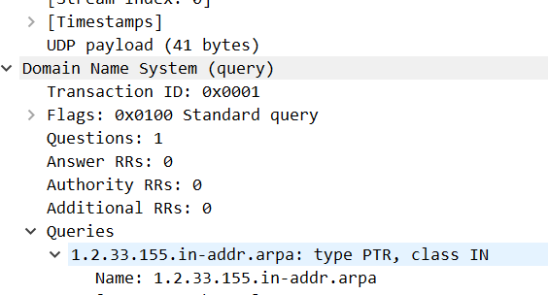

15. Examine the DNS response message to the query message. How many

“questions” does this DNS response message contain? How many “answers”? (4

Points

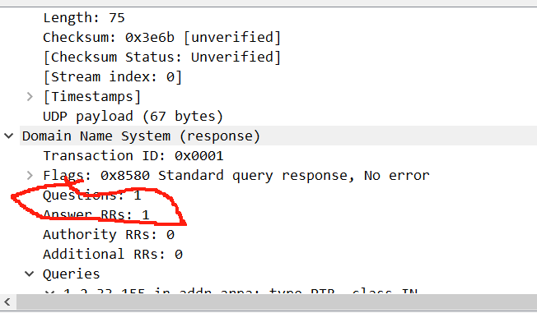

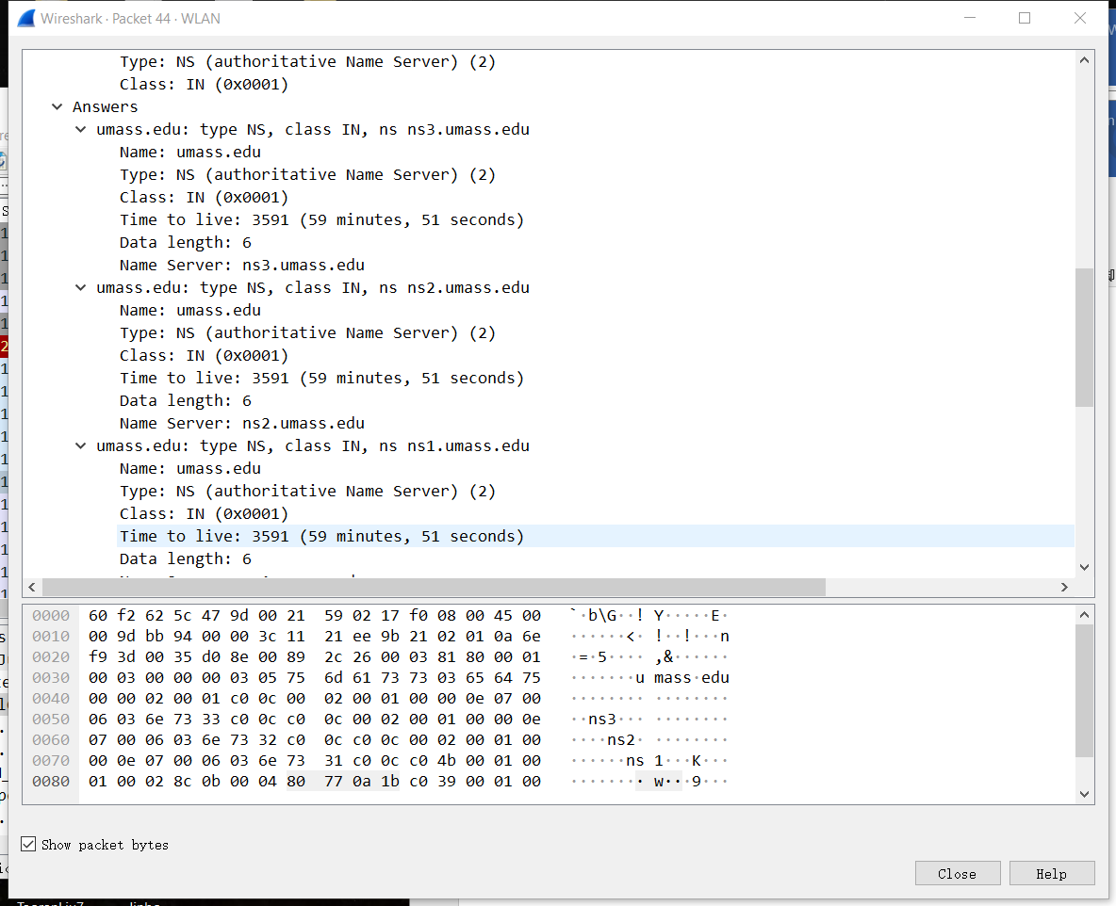

19

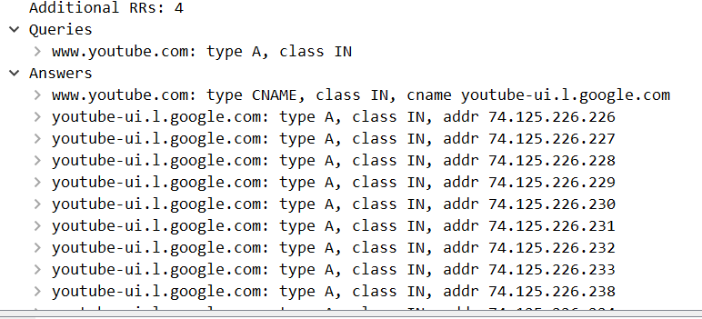

20

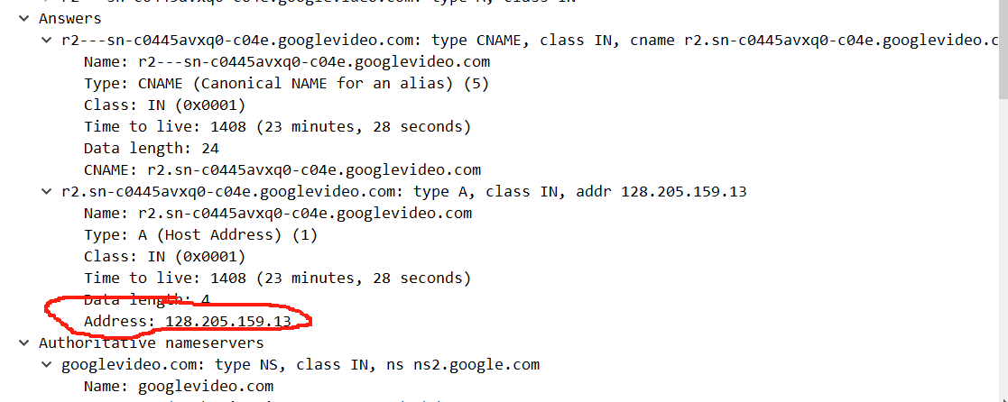

21

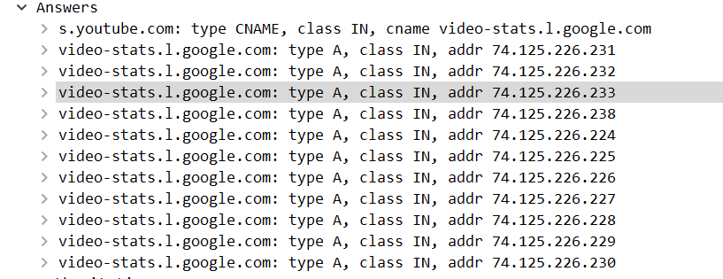

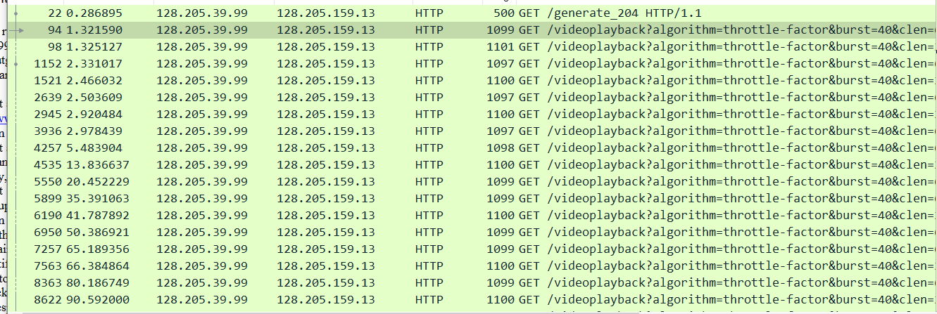

24

